**Meeting attendees**

Yijun Zhou, Om Arora Jain

**Meeting time**

12:00–12:30 pm 2023.07.05

**Meeting Agenda**

1. Talk about what should be in Results Analysis part
2. Share the small functions

Plottrend.py (1, 4, 10)

Plottrend.py (1, 4, 9)

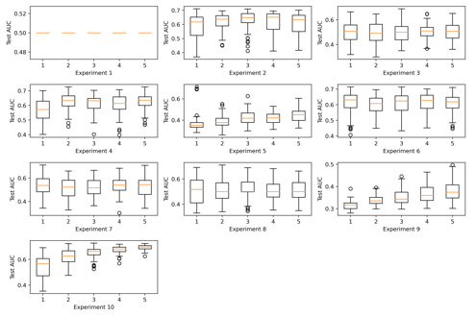

3. imed.odpac.net do the test on DataAnalysis part

4. think of writing a user manual for imed (like an instruction for all functions and how to use them)

**Progress made in the past week.**

**Issues/Questions**

**Comments**

**In terms of the plan for writing:**

**Overall Goal of the entire training session.**

1. Putting together the manuscript for SHGS.
2. Develop a user manual for iMed?

**Specific tasks for the coming week**

**Less urgent tasks**